

NATIONAL OPEN UNIVERSITY OF NIGERIA
UNIVERSITY VILLAGE, PLOT 91 CADASTRAL ZONE, NNAMDI AZIKIWE EXPRESS WAY, JABI - ABUJA.
FACULTY OF SCIENCES
DEPARTMENT OF PURE AND APPLIED SCIENCES
NOVEMBER 2018, SECOND SEMESTER EXAMINATION

COURSE CODE: CHM 391
COURSE TITLE: PRACTICAL CHEMISTRY V – INORGANIC AND ANALYTICAL
CREDIT UNIT: TWO (2)
TIME: 2 HOURS
INSTRUCTION: Question one is compulsory. Answer question one and any other three
questions.

QUESTION ONE
1ai. Enumerate the experimental procedure of determination of functional groups present in an organic sample. (5marks)
1aii) State the kind of molecules that absorb infrared radiation. (1 mark)

1bi. Mention the significant difference between potentiometric titration and classical titration.
(3 marks).
1bii) If the values presented in the table below were obtained when 100 ml of a water sample was titrated with 0.04 M H₂SO_{4,} determine the total alkalinity of this water sample.
NO of titration | Volume of sample (mL) | Initial burette reading | Final burette reading | Volume of Sulphuric (mL)
1 | 100 | 0.00 | 6.40 | 6.40
2 | 100 | 0.00 | 6.50 | 6.50
3 | 100 | 0.00 | 6.50 | 6.50

(5 marks)
1ci) Mention the uses of the following:
- Gravimetric analysis
- Potentiometric titration
- UV- Visible spectroscopy
- Colorimetry
- Infrared spectroscopy
- Atomic absorption spectroscopy (6 marks)
1cii) What are the sources of acidity in a water body and why is it necessary to determine acidity of a water sample. (5 marks)
QUESTION TWO
2a. The concentration of an organic compound is to be determined using UV-visible spectrophotometer, if the wavelength of maximum absorption (λ max) of this organic compound is unknown, use the information provided below to obtain the wavelength of maximum (λ max) at which the determination will be carried out.

Absorbance(s) of the organic compound | Wavelengths of absorption of the organic compound (nm)
0.100 | 360
0.110 | 380
0.120 | 400
0.125 | 420
0.130 | 440
0.160 | 460
0.165 | 480
0.400 | 500
0.60 | 520
1.00 | 540
1.10 | 560
0.80 | 580
0.40 | 600
0.10 | 620
0.11 | 640
0.12 | 660

(12 marks)

2b. Differentiate between qualitative analytical groups and groups of the periodic table.
(3 marks)

QUESTION THREE
3a) Atomic Absorption Spectroscopy (AAS) was used to determine the concentration of chromium in an imported rice sample, in the course of the analysis, standard solutions of chromium were prepared and their absorbance read at 550nm, producing the data below. Use this data to determine the concentration of chromium in the rice sample whose absorbance is 0.60.
Standard | Concentration (mol/L) | Absorbance
1 | 0.00008 | 0.124
2 | 0.00016 | 0.239
3 | 0.00040 | 0.614
4 | 0.00080
(11 marks)

3b) Outline the procedure of determination of concentration of an analyte by colorimetry.
(4 marks)
QUESTION FOUR
4a) Outline and explain briefly the steps involved in gravimetric analysis. (12 marks )

4b) How would you set the absorbance of UV-Visible spectrophotometer at zero (0)?
(3 marks)

QUESTION FIVE
5a) Use the table of characteristic infrared absorption bands of organic functional groups provided to identify the functional groups present in an organic molecule whose IR spectrum appear below.
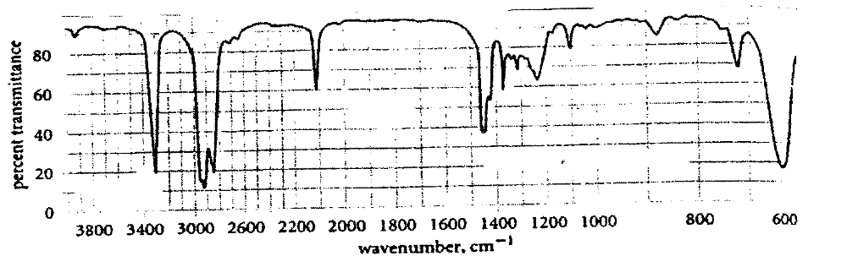

CHARACTERISTIC INFRARED ABSORPTION BANDS OF FUNCTIONAL GROUPS
Class of compounds | Absorption cm⁻¹ | Intensity | Assignment
Alkanes and Akyls  Alkenes  Alkynes  Ethers  Aldehydes  Carboxylic acids  Alcohols | 2850 – 3000  1450 – 1470  1370 – 1390  1365 +1395  Two bands  715 - 725  3020-3140  1640-1670  910+990  Two bands  885-895  665-730  960-980  790-840  3265-3335  2100-2140  610-700  2190-2260  1085-1150  1020-1075 and  1200-1275  (Two bands)  2700-2725  1720-1740  1685-1710  1100  2500-3500  1710-1715  1680-1710  3300 – 3400  1125 - 1205 | s  s  m  m  w  w-m  vw-m  m+s  s  m-s, broad  s  s  s  m  s  vw-w  s  m  m  s  s  m  s bend  s, broad  s, broad  s, broad  m - s | C – H stretch  C- H bend  CH_{2,} C – H bend  -CH(CH₃)₃ bend  -(CH₂)n bend  =C-H Stretch  C=C Stretch  =C-H bend  =C-H bend  =C-H bend  =C-H bend  =C-H bend  =C-H Stretch  C=C Stretch  =C-H bend  C=C Stretch  C-O-C Stretch  =C-O-C sym and asym stretch  H-C=O Stretch  C=O Stretch  C=O Stretch  C-C-C bending  O-H Stretch  C=O Stretch  C=O Stretch  O – H stretch  C –O stretch

Intensity abbreviations: vw = very weak, w = weak, m = medium, s = strong, vs = very strong
(10¹/₂ marks)
5b) Deduce from the identified functional groups what class of organic compound it is whose IR spectrum appear in 5a above. (4¹/₂ marks)

