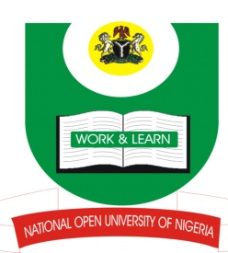

NATIONAL OPEN UNIVERSITY OF NIGERIA
Plot 91 Cadastral Zone Nnamdi Azikiwe Expressway
Jabi – Abuja
FACULTY OF SOCIAL SCIENCES
DEPARTMENT OF POLITICAL SCIENCE
2017_2 POP EXAMINATION
PROGRAMME: Peace Studies and Conflict Resolution

COURSE CODE: PCR 419
COURSE TITLE: INTERNATIONAL POLITICS OF THE COLD WAR
CREDIT UNIT: 3
TIME ALLOWED: 3 HRS
INSTRUCTIONS: ANSWER ANY FOUR QUESTIONS. ALL QUESTIONS CARRY EQUAL MARKS

- The military strategy of the Warsaw Pact as envisioned by the Soviet Union was to inflict rapid and decisive defeat of the North Atlantic Treaty Organization. Discuss? (17.5marks) marks)

- Discuss the composite goals of the European Recovery Programme as a strategy of containment (17.5 marks)

- Several events culminated in the relaxation of tension between the key adversaries of the Cold War. Discuss (17.5 marks)

- Discuss the conflict trajectories that made the Cold War a social conflict (17.5 marks)

- Attempt a comparative analysis of Marshall and Molotov Plans (17.5 marks)

- International politics in anarchical world is predicated upon countries pursing their strategic self-interest as far as their power would allow them. Discuss. (17.5 marks)

