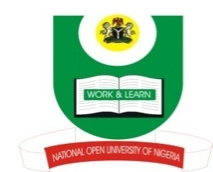

NATIONAL OPEN UNIVERSITY OF NIGERIA
Plot 91 Cadastral Zone, University Village, Nnamdi Azikiwe Expressway, Jabi Abuja
2017_2 EXAMINATION
Programme: B. A. Islamic Studies
Name of Subject: Islamic Studies
Course/Title: ISL339: Islamic Family Law
Instruction: Answer question number two and any other two

Q1. Explain what is meant by Islamic Family Law and what are the areas it covers?
(23 marks)

Q2. Discuss some of the roles prescribed for husband and wife under the Islamic Family
Law. (24 marks)

Q3: Discuss the position of Islam on marriage with People of the book and the
Polytheists. (23 marks)
Q4. With the aid of some relevant Qur’anic verses and Prophetic traditions, discuss
marriage as a social contract. (23 marks)

Q5. Discuss on the temporarily and the permanently prohibited degrees of marriage.
(23 marks)

