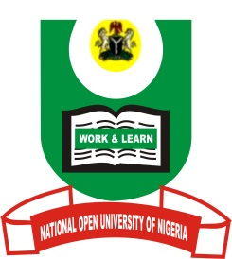

NATIONAL OPEN UNIVERSITY OF NIGERIA
FACULTY OF SOCIAL SCIENCES
DEPARTMENT OF POLITICAL SCIENCE
JANUARY/FEBRUARY 2017_2 EXAMINATION QUESTIONS

COURSE CODE: INR 361
COURSE TITLE: RELIGION, ETHNICITY AND NATIONALISM IN INTERNATIONAL POLITICS
INSTRUCTIONS: ANSWER ANY FOUR QUESTIONS
TIME ALLOWED: 3 HOURS

1. Define the concept Religion and discuss two approaches to understanding religion. (17.5Marks)

2. What is ‘Ethnicity’? Identify and discuss the types of ethnic groups in International politics. (17.5Marks)

3. Using any three theories of ethnic conflict, explain why ethnic conflicts occur. (17.5Marks)

4. Discuss the view that the phenomenon of globalization has eroded distinct ethnic identities across the world. (17.5Marks)

5. Discuss the position that religion has altered the contours of international politics. (17.5Marks)

6. Using several contemporary examples, explain how most international conflicts are instigated by religion. (17.5Marks)

