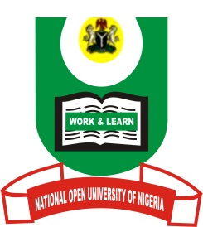

NATIONAL OPEN UNIVERSITY OF NIGERIA
DEPARTMENT OF POLITICAL SCIENCE
FACULTY OF SOCIAL SCIENCES
JANUARY/FEBRUARY 2017_2 POP EXAMINATION QUESTIONS

COURSE CODE: INR 302
COURSE TITLE: The Media and International Relations
INSTRUCTION: Answer any three question
TIME ALLOWED: 3 Hours

Question 1: Discuss the concept Mass Media and International Relations.
Question 2: The freedom of the press in Nigeria is an illusion. Do you agree? Justify your position
Question 3: Discuss the various ways the media is transforming International relations in the contemporary world.
Question 4: The principal focus of Foreign policy is the pursuit of national interest of states. Do you agree? Discuss the core objectives of national interest of states.
Question 5: Examine the processes of foreign policy making in the contemporary world order.
Goodluck

