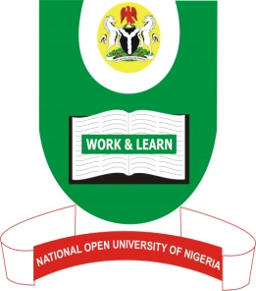

NATIONAL OPEN UNIVERSITY OF NIGERIA
DEPARTMENT OF RELIGIOUS STUDIES
FACULTY OF ARTS

QUESTIONS

End of Semester Examination 2017
Programme:PGD in Christian Theology
Course Code:CTH 7022 Credit Units
Course Title:COMMON THEMES IN CHRISTIANITY AND ISLAM
Time Allowed:2hrs
Instruction: Answer question 1 and any other 2 questions.

- “Wealth and Children are ornament of the world”. Discuss.
- Write short notes on the following:
- The love of God
- Charity and The last day
- Discuss the healing methods used in both the Bible and the Quran.
- Account for the result of Adam’s sin.
- Write briefly on Zakah.

