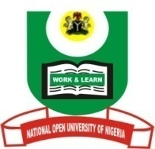

NATIONAL OPEN UNIVERSITY OF NIGERIA
University Village, Nnamdi Azikiwe Expressway, Pl0t 91, Cadastral Zone Jabi Abuja
FACULTY OF ARTS
July, 2017 Examination

END OF SEMESTER EXAMINATION 2017_1

Programme: B. A. Islamic Studies
Name of Subject: Islamic Studies
Course/Title: ISL436: Islamic Law of Waşiyyah and Waqf
2.0 Units Time Allowed: 2 hrs
Instruction to Candidates: Answer only THREE questions in all.
1a. Define waqf (Endowment) technically and discuss liquidation of it. 10 Marks
b. Differentiate between Waşiyyah (Will) and Waqf (Endowment) 13 Marks.
2. List some of the institutions of Islam which alleviate poverty in the society.
23 Marks
3. Explain the word Al-infaq and its kinds. 24 Marks
4. 4a. Give the literal and legal meanings of şadaqah. 8 Marks
b. Differentiate between şadaqah and zakāh. 15 Marks.
5.a. In what ways can a Muslim maintain his immediate family? 11Marks.
b. As an Islamic scholar what you can suggest as way-out from this recession in Nigeria. 12 Marks.

