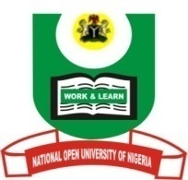

NATIONAL OPEN UNIVERSITY OF NIGERIA
University Village, Nnamdi Azikiwe Expressway, Pl0t 91, Cadastral Zone Jabi Abuja
FACULTY OF ARTS
July, 2017 Examination

END OF SEMESTER EXAMINATION 2017_1
Course Code: ISL402
Course Title: Modern Reform Movements
Credit Units: 2
Time Allowed: 2 hrs.

Instruction to candidates: Answer only THREE questions.
Question Number One (1) is compulsory.

- Examine the term, tajdid and situate it within the context of Islam in Nigeria.
(24 Marks)

- Assess the position of the Ottomans and the Moguls during the 18th century world politics. (23 Marks)

- Examine the basis for modern reform movements in Islam. (23 Marks)

- Why is the Wahhabiyyah so prominent as a revival/reform movement in Islam in the modern time? (23 Marks)

- “Al-Afghani borrowed from the West for the improvement of Muslim societies.” Discuss. (23 Marks)

Notes: Three (3) questions are to be attempted in all.
23 marks times 2 = 46
24 marks for question number 1
Total marks for exam = 70

