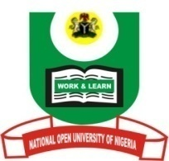

NATIONAL OPEN UNIVERSITY OF NIGERIA
University Village, Nnamdi Azikiwe Expressway, Pl0t 91, Cadastral Zone Jabi Abuja
FACULTY OF ARTS
July, 2017 Examination

END OF SEMESTER EXAMINATION 2017_1

Course Code: ISL304
Course Title: Islamic Studies and Orientalism
Credit Unit: 2.0 Units
Time Allowed: 2 hrs

Instruction: Answer any THREE of the following questions.

- As an Islamic studies student how would you react to the criticism and allegation of Orientalists that Prophet Muhammad promoted merciless killings? (23 marks)

- Counter critics’ allegations against Prophet Muhammad over his marriages and his claim to prophethood? (24 marks)

- Briefly outline and assess the views of both Williams Muir and Samuel Margoliouth on divine revelation as established in their works. (23 marks)

- A. Define the term Orientalism? (10 Marks)
B. How did Orientalism emerge as an academic pursuit? (13 Marks)

- What is Orientalists’ fault finding of Prophet Muhammad’s marriages and prophethood? (23 marks)

