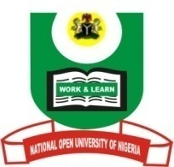

NATIONAL OPEN UNIVERSITY OF NIGERIA
University Village, Nnamdi Azikiwe Expressway, Pl0t 91, Cadastral Zone Jabi Abuja
FACULTY OF ARTS
July, 2017 Examination

END OF SEMESTER EXAMINATION 2017_1
Programme: M. A. Christian Theology
Course Code: CTH 847 3 Credit Units
Course Title: African Church Leaders
Time Allowed: 3hrs
Instruction: Answer question 1 (30 marks) and any other Two (20 marks each)

- What personal lesson(s) have you learnt from the ministry and life of Bishop Ajayi Crowther? (30 marks)
- Describe the impact of the Nationalist revolution on the spread of Christianity in Africa (20 marks)
- Discuss Kumuyi’s contribution to the growth of Christianity in Africa (20 marks)
- Enumerate the Africans who contributed to early Christian theology (20 marks)
- Discuss the various groups among the Independent Religious movements in Africa. (20 marks)

