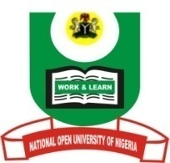

NATIONAL OPEN UNIVERSITY OF NIGERIA
University Village, Nnamdi Azikiwe Expressway, Pl0t 91, Cadastral Zone Jabi Abuja
FACULTY OF ARTS
July, 2017 Examination

END OF SEMESTER EXAMINATION 2017_1
Programme: M.A. Christian Theology
Course Code: CTH 842 3 Credit Units
Course Title: Religion, Power and Politics in Contemporary Nigerian Society
Time Allowed: 2 hrs
Instruction: Answer question one and any other two questions

- Discuss the sources of power in contemporary Nigerian society (30 Marks)

- Analyze the contributions of philosophers to the development of politics during reformation period (20 Marks)

- Examine the features of politics in contemporary African society (20 Marks)

- Define power and show how it relates to people in Nigeria (20 marks)
- What are the problems hindering the growth of new religious movements in Nigeria
(20 Marks)

