

**National Open University Of Nigeria**

**Plot 91, Cadastral Zone, Nnamdi Azikiwe Expressway, Jabi - Abuja**

**Faculty of Science**

**October/November 2016 Examination**

**COURSE CODE: PHY 308**

**COURSE TITLE: ELECTRONICS I**

**CREDIT UNIT: 2**

**TIME ALLOWED (2 HRS)**

**INSTRUCTION: Answer any 4 questions**

**QUESTION ONE**

1. What is meant by the term Integrated Circuit (2 Marks)
2. State any two characteristics of an ideal Op-amp. (2 Marks)
3. Sketch the CE-configuration transistor output characteristics of a transistor and

indicate the active, cut-off and saturation regions. (4 Marks)

1. Define the following: Mark-to-Space Ratio (MSR), Pulse Repetition Time (PRT), and Pulse Repetition Frequency (PRF). (6 Marks)

**QUESTION TWO**

For the emitter bias network of Fig 4, determine:

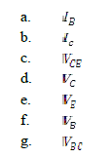 

Fig 4: Emitter bias network

(14 Mrks)

**QUESTION THREE**

In the series-parallel (SP) feedback amplifier of Fig. 5, Calculate:

(a) Open-loop gain of the amplifier 3Mrks

(b) Gain of the feedback network 3Mrks

(c) Closed-loop gain of the amplifier 3Mrks

(d) Sacrifice factor, S. 3Mrks

**QUESTION FOUR**

Evaluate the voltage gain for the circuit shown in Fig. 2, with RF = 195KΩ

and R1=10 KΩ

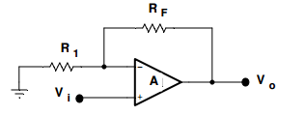(4 Marks)

Fig 2: Op-amp

1. Calculate the output of the circuit in Fig 3. for RF = 68 kΩ

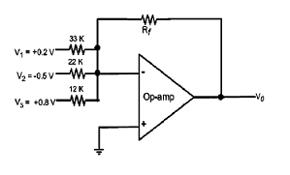 Fig 3: Summing Amplifier (6 Mrks)

1. Draw a diagram to represent a complete solid state power supply . (4 Marks)

|  |
| --- |
|  |

**QUESTION FIVE**

1. What is an op-amp? (2 Marks)
2. State three uses of op-amp (3 Marks)
3. With the help of a neat diagram, explain the operation of a Bridge Rectifier. (4 Marks)

1. What is Peak Inverse Volatge? (2 Marks)

Classify the following filter as active/passive and low pass/high-pass as appropriate (3 Marks)

  Fig. 5 Fig. 6

+



Fig. 7

**QUESTION SIX**

1. The Zener diode of Fig.8 has the following ratings:

VZ = 6.8 V , IZ = 50 mA@ rz = 2Ω. IZ(min) = 5mA , IZ (max) = 150mA



Fig.8

What would be the load voltage when load current IL varies from 10 mA to 120

mA? Also, calculate voltage regulation of the regulator. (10 Marks)

State three advantages and one disadvantage of class A amplifier. (4 Marks)