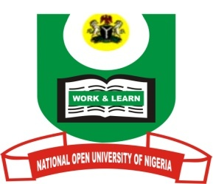
National Open University of Nigeria
School of Arts and Social Sciences
Mass Communication Programmes
October 2016 Examination
Course: MAC 427: Economic and Social Issues in Advertising and Public Relations
Instruction: Answer question one which is compulsory with any other two.

- a.) Discuss how consumerism operates in Nigeria bearing in mind Organizations that are set up for this purpose. (15 marks)
b). Discuss five demerits of consumerism in Nigeria. (15 marks)

- Adequately discuss any five objectives of the Institute of Public Relations (20 marks)

- a.) Public Relations is a management function. Discuss briefly. (10 marks)
(b) Give five roles of Public Relations in management. (10 marks)

- a.) What is a marketing mix? (4 marks)
(b) Discuss the four components of the marketing mix. (16 marks)

- a.) Briefly discuss the term ethics and its implication to the practice of advertising and Public Relations. (8 marks)
b. According to Ayozie (2011), there are constraints that impinge on free choice by a person. Discuss three. (12 marks)

