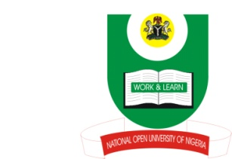

National Open University of Nigeria
Plot 91, Cadastral Zone, Nnamdi Azikiwe Express Way
Jabi - Abuja

Faculty of Education
October/November Exanimation 2016

Course Code: EGC 815
Course Title: Sex, Family and Marital Counselling
Credit Unit: 2 Units
Time Allowed: 2 Hours
Instructions: Attempt Questions One And Any Other 2.

1(a) what is human sexuality? (5mks).
(b) Discuss two functions of sex/human sexuality. (2x4=8mks).

(c). Highlight the four phases of Sexual Response Cycle. (4x3=12mks).
2(a) what is Sexual Dysfunction? (4mks).
(b) Discuss any four types/causes of sexual dysfunctions. (4x4=16mks).
3(a) Define the term Mating. (4mks).
(b) Discuss four types of problems associated with mating. (4x3=12mks).

4(a) Define Premarital Sex. (5mks).
(b) Justify five reasons why Premarital Sex is very rampant in the society today. (15mks).

Grand total= 30+20+20= 70mks.

