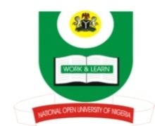

NATIONAL OPEN UNIVERSITY OF NIGERIA, ABUJA
Plot 91, Cadastral Zone, Nnamdi Azikwe Express Way, Jabi-Abuja

FACULTY OF ARTS
October/November Examinations 2016

Course Code: CTH 845
Course Title: Islam and State
Credit Unit: 3
Time Allowed: 3 hrs

Instruction: Answer question one and any other two questions

- Write short notes on the followings:

- Prophet Mohammad
- Prophet Isa bn Maryam
- Prophet Ibrahim
- Prophet Musa (30 Marks)

- Discuss the development of Islamic socialism in Muslim dominated countries in Africa
(20 Marks)

- Examine the impact of Islam on Nigerian society (20 Marks)

- List the seven theories of Islamic state and discuss four of them (20 Marks)

- Explain the political characters of Islam in Nigeria (20 Marks)

