NATIONAL OPEN UNIVERSITY OF NIGERIA
PLOT 91, CADASTRAL ZONE, NNAMDI AZIKIWE EXPRESSWAY, JABI - ABUJA
FACULTY OF SCIENCE
OCTOBER/NOVEMBER 2016 EXAMINATION
COURSE CODE: | CIT754
COURSE TITLE: | DIGITAL COMMUNICATIONS
CREDIT UNITS: | 3
TIME ALLOTED: | 2 HOURS, 30 MINUTES
INSTRUCTION: | Answer any FIVE questions. Cordless nonprogrammable calculators may be used.
1.
a.) Write down the expression for a bandpass digitally modulated signal in terms of the information sequence (I₁, I₂, I₃, … I_{n-2}, I_{n-1}, I_{n}).
b.) Briefly define what a lowpass (baseband) signal is.
c.) Sketch the spectrum of a real-valued lowpass signal. (14 marks)
2.
a.) Distinguish between block and convolutional codes.
b.) Briefly define the rate of a code.
c.) Derive an expression for the transmission rate R in terms of the code rate R_{c}, the constellation size (M) and the symbol duration T_{s}. (14 marks)
3.
a.) Briefly explain what a finite field is.
b.) Define what an Abelian group is listing its four main properties.
c.) Distinguish between Rayleigh and Ricean fading channels. (14 marks)
4.
a.) Derive an expression for the rate of a Hamming code.
b.) Generate the parity check matrix H for a (7,4) Hamming code.
c.) Briefly describe the concept of diversity techniques for multipath fading channels.
(14 marks)
5.
a.) Using a suitable diagram, describe the graphical technique for determining the error-correction capability of an (n,k) code.
b.) Distinguish between a perfect code and a quasi-perfect code.
c.) Briefly describe the concept of a RAKE demodulator. (14 marks)
6.
a.) With the aid of a suitable diagram, describe the structure of a convolutional encoder.
b.) Derive the code that will be generated by the convolutional encoder shown in Fig. Q6b if the input sequence is u = (100111).
c.) Briefly explain what a frequency-selective channel is. (14 marks)
7.
a.) Briefly describe what a space-time block code (STBC) is.
b.) Write down the generated matrix for the Alamouti code and hence determine the value of the corresponding spatial code rate R.
c.) Briefly explain what a slowly fading channel is. (14 marks)

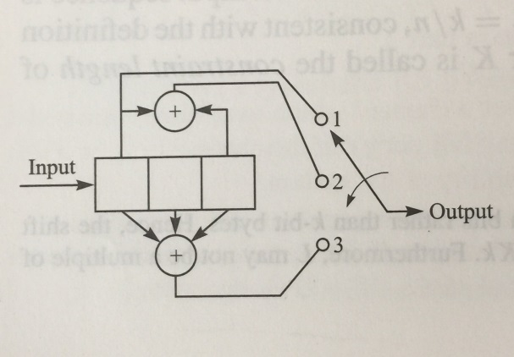
Fig. Q6b: K=3, k = 1, n = 3

