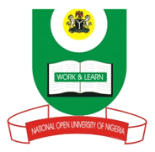
NATIONAL OPEN UNIVERSITY OF NIGERIA
14-16 AHMADU BELLO WAY, VICTORIA ISLAND LAGOS
MARCH/APRIL 2016 EXAMINATION
SCHOOL OF ARTS AND SOCIAL SCIENCES

COURSE CODE: INR412
COURSE TITLE: FOREIGN POLICIES OF GREAT POWERS

TIME ALLOWED: 3 Hours
INSTRUCTION: Answer any 3 questions.
- Examine the extent to which the economic relationship between China and Africa are mutually beneficiary to both parties? (23 Marks)

2. Critically examine the various ways in which the external environment influences the formulation of foreign policy decisions. (23marks)

3. Discuss the main reasons why France was reluctant to dismantle its colonial empire after the end of the Second World War? (23 Marks)

4. Discuss the impact of the Second World War on the decolonisation process in the British Empire (23 Marks)

5. Using a rational decision making model, explain how you would react to a sudden attack of your country by an enemy state. (23 Marks)

