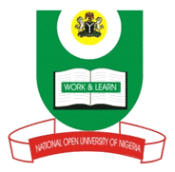
NATIONAL OPEN UNIVERSITY OF NIGERIA
14-16 AHMADU BELLO WAY, VICTORIA ISLAND LAGOS
MARCH/APRIL 2016 EXAMINATION
SCHOOL OF ARTS AND SOCIAL SCIENCES

Course Code: CTH 832
Course Title: New Religious Movements in Africa

Time Allowed: 3hrs
Instruction: Answer questions one and any other two questions.

- State the origin of each of the major religious groups in Nigeria.
- Identify the contribution of the three major religion groups towards the spread of gospel in Nigeria.
- Discuss the reason why Christians are united as one body in Jesus Christ.
- List the objectives of the Christian Association of Nigeria.
- Explain the origin of Ifa.

