NATIONAL OPEN UNIVERSITY OF NIGERIA
14-16 AHMADU BELLO WAY, VICTORIA ISLAND LAGOS
SEPTEMBER/OCTOBER 2015 EXAMINATION

SCHOOL OF SCIENCE AND TECHNOLOGY

COURSE CODE: CIT 341
COURSE TITLE: DATA STRUCTURES

INST RUCTION: Answer anyfive questions out of Seven
Time: 3HOURS

1 .

- Distinguish b etweenlinear and non‐linear data structures

- Write a brief note on each of the foll owing:

  - Arra y

  - List

- D istinguish between a queue and a stack. Illustrate your answer.

2 .

a) C onsider the following o perationscarried out on a queue Q. Provide the content of t he q ueue and th e returnedvalue, after each operat on, to comp lete the table.

 | O peration | Conte nt of Q | Returned Value
 | I nitialise(Q)
 | A dd(A,Q)
 | A dd(D,Q)
 | A dd(O,Q)
 | R emove(Q)
 | A dd(T,Q)
b) | R emove(Q)
 | U sing a simple example e xplain how a queue is stored in a dynamic data tructure
 | describing ho w a node ca n be added and removed.
c) | B riefly describe two modes of stackstorage.

3 .

- B riefly explain what a hash function is.

- List the three characteristics of a good hash function.

- E xplain what a hash table is mentioning an exam ple of its app lication.

4 .
a) | Write down the mathematical definition of a tree mentioning | the required properties .
b) | B riefly explain the recursive nature of the above definition of | a tree.
c) | U sing an exampledescrib e the inverted pictorial representation of a tree .
5 .

- B riefly describe what a search tree is mentioning its salient p roperties.

- G ive a concise definition of a perfect binary tree.

- U sing the simple tree shown in the fi gure below a s an example, describe the followin g traversal methods:
- Preorder

- Post order

- Inorder.
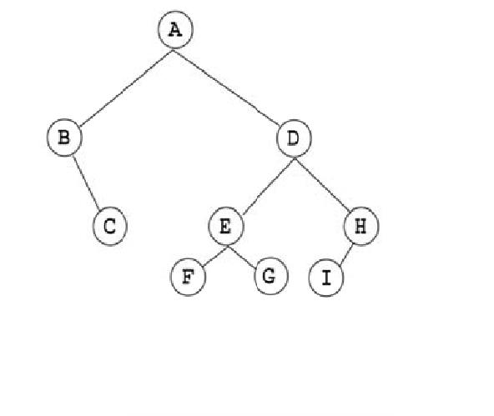

6 .

a) B riefly explain the concept of garbage and how it accumulate s in a Java Programme

b) Write short n otes on the following garbagecolletiontechniques

i. Refeence Counting

ii. Mark ‐and‐Sweep

c) B riefly describe four Memory Allocation methods.

7 .

a) E xplain clearly what greedy algorith is.

b) D escribefouconstituen t functionso f greedy algorithm

c) B riefly describe the three phases of the divide‐and‐conquer paradigm

