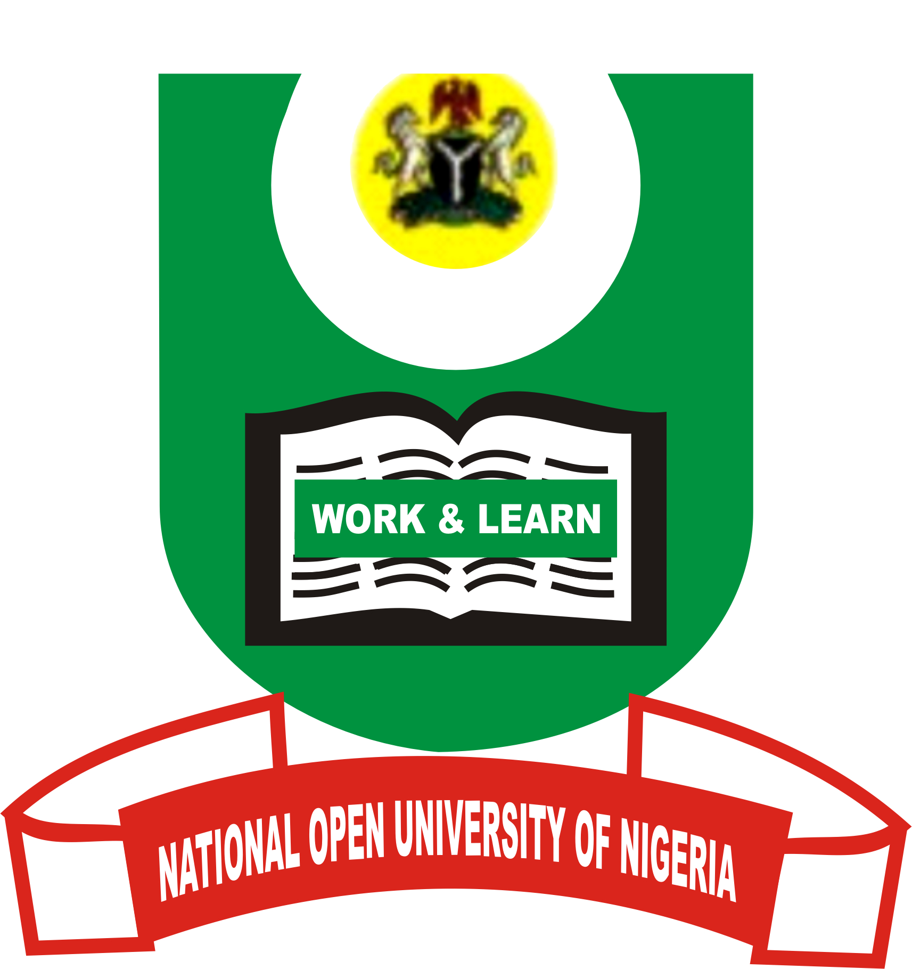

NATIONAL OPEN UNIVERSITY OF NIGERIA
14/16 AHMADU BELLO WAY VICTORIA ISLAND LAGOS
SCHOOL OF ARTS AND SOCIAL SCIENCES
MARCH/ APRIL 2014 POP EXAMINATION
COURSE CODE: PCR 422
COURSE TITLE: GLOBALIZATION AND PEACE
TIME ALLOWED: 3 HOURS

Instruction: Answer any three (3) questions of your choice
1. Discuss the various myths that have been built up around globalization?
23 marks

2. Discuss the role of humanitarian players in a globalizing world, and how the
weak can participate in the globalization process? 23 marks

3. Outline and discuss the four major stages of conflict resolution and support
for peace as presented by the United Nations. 23 marks

4. Discuss the role of education in cultural identity formation, and suggest
outlines of a global education policy for peace. 23 marks

5. What is peace? Discuss this in the context of conflict and co-operation for
peace building in globalization. 23 marks

