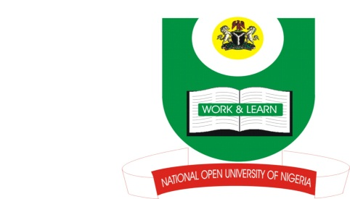

NATIONAL OPEN UNIVERSITY OF NIGERIA
14/16 AHMADU BELLO WAY,VICTORIA ISLAND, LAGOS.
SCHOOL OF ARTS AND SOCIAL SCIENCES

MARCH/APRIL 2014 EXAMINATION

COURSE CODE: INR412
COURSE TITLE: FOREIGN POLICIES OF GREAT POWERS
TIME ALLOWED: 3 Hours

INSTRUCTION: Answer any 4 questions

1. Describe the process of European enlargement from 1957 to 2007 (17 Marks)

2. Critically examine the changing trends of Soviet Union foreign policy from the period
of revolution to the Second World War. (17 Marks)

3. In a globalising world, it is difficult for states to claim exclusive rights and
responsibilities over foreign policies. How true is this assertion? (17 Marks)

4. What do you consider as the main reasons for the reluctance of France to dismantle
its colonial empire after the end of the Second World War? (17 Marks)

5. How relevant are the Chinese’s five principles of peaceful coexistence in
contemporary International Relations? (17 Marks)

6. What do you consider to be the impact of the Second World War on the
decolonisation process in the British Empire? (17 Marks)

