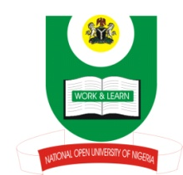
NATIONAL OPEN UNIVERSITY OF NIGERIA
14/16 AHMADU BELLO WAY, LAGOS

SCHOOL OF EDUCATION
MAY/JUNE 2013 EXAMINATION

COURSE CODE: ECE 311
COURSE TITLE: INTRODUCTION TO CULTURAL AND CREATIVE ARTS

Instructions: Answer question 1, which is compulsory and any other two questions.

Time Allowed: 2 Hrs.

1 a) What is culture?

b) Briefly discuss the following characteristics of culture
- Sharing in culture
- Culture and learning

c) Distinguish between Social and Material culture.

2 a) i. Give a concise definition of the concept language.
ii. What is linguistics? Clearly distinguish between morphology and syntax.

b) i. What do you understand by language acquisition?
ii. Discuss the two major processes in language acquisition.

3 a) Name the principal types of sculpture.

b) Briefly discuss carving and casting as techniques used in sculpture.

c) Write a short note on the art of drawing.

4 a) i. Give a definition of performing arts
ii.what is drama

b) Identify the various components that make up drama

c) Name and describe two types of drama.

