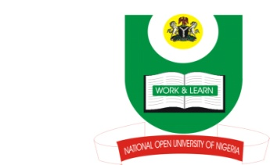
DEADEADEADEADEADEADEADEADEADEADEADEADEA

NATIONAL OPEN UNIVERSITY OF NIGERIA
School of Arts and Social Sciences

2013 EXAMINATIONS
DATE: SATURDAY 26TH JANUARY, 2013

Programme: B. A. Islamic Studies
Name of Subject: Islamic Studies
Course/Title: ISL339: Islamic Family Law 2.0 Units Time Allowed: 2 Hours
Instruction to Candidates: Answer only THREE questions in all

1. Explain the concept and scope of Islamic Family Law.

2. With the aid of some relevant Qur’anic verses and Prophetic traditions, discuss
marriage as a social contract.

3. Discuss the Shariah provisions on the temporarily and the permanently prohibited
degrees of marriage.

4. Discuss the position of Islam on marriage with People of the book and the Polytheists.

5. Mention thirteen roles prescribed for husband and ten roles prescribed for wife under the Islamic family law.

