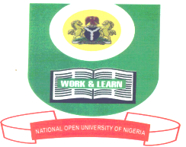

NATIONAL OPEN UNIVERSITY OF NIGERIA
14-16 AHMADU BELLO WAY, VICTORIA ISLAND, LAGOS
SCHOOL OF MANAGEMENT SCIENCES
JANUARY/FEBRUARY 2013 EXAMINATION

COURSE CODE: HCM 339

COURSE TITLE: FOOD AND BEVERAGE PRODUCTION III

TIME ALLOWED: 2Hrs

Instructions: 1. Attempt question number one (1) and any other two (2).
2. Question number 1 is compulsory and carries 30 marks while the other 2 questions carry 20 marks each.
3. Present all your points in coherent and orderly manner

- (a) Explain why foods should be coated before deep-frying
(b) Discuss the types of fats used for deep-frying
(30 marks)
- Describe and discuss four methods of moist heat used in cooking(20 marks)
- (a) Why do we boil our foods?
(b) What are the benefits of boiling our meat and poultry before eating them?
(20 marks)
- (a) Describe the methods of steaming used in cooking?
(b) What are the effects of steaming on food?
(20 marks)
- (a) Describe the ingredients required for frying eggs?
(b) What is the procedure for cooking fried egg?
(20 marks)
1302111018

