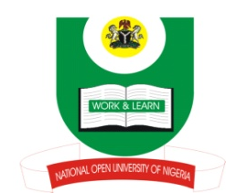

NATIONAL OPEN UNIVERSITY OF NIGERIA
14-16 AHMADU BELLO WAY, VICTORIA ISLAND, LAGOS
SCHOOL OF EDUCATION
JANUARY/FEBRUARY 2013 EXAMINATION

COURSE CODE: EDU 421

COURSE TITLE: Guidance & Counselling

CREDIT UNITS: 2 TIME: 2 HOURS

INSTRUCTION: Attempt 3 questions out of 4. Question 1 is compulsory

1(a). What is Guidance and counselling?
(b) Explain five importance of Guidance and Counselling in our school and society
(c) List five counselling techniques you know
(30marks)

- (a) What are the major problems militating against the effective implementation of Guidance and Counselling Programme in Nigeria schools? List five of the problems.
(b) Explain ways out of the five listed in (a) above.
(20marks)
- Explain five of the major objectives of guidance and counselling
(20 marks)

- How can a Guidance and Counselling programme be planned and administered in schools
(20marks)
1302081018

