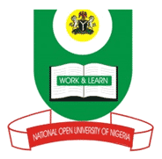

NATIONAL OPEN UNIVERSITY OF NIGERIA
14-16 AHMADU BELLO WAY, VICTORIA ISLAND LAGOS
SCHOOL OF ARTS AND SOCIAL SCIENCES
MAY/JUNE 2012 EXAMINATION

PCR424: GOVERNANCE, INTERNATIONAL LAW, AND FUNDAMENTAL HUMAN RIGHTS

Time Allowed: 2 Hours

Instruction: Answer any three (3) questions of your choice

- Is godfatherism an African concept? Can it be eradicated in Nigeria political structure? Discuss.

- Why is Democracy and Constitutionalism not well entrenched in African political mainstream? Explain.

- ‘’Without women participation in peace process and politics in any society, there can hardly be sustainable peace and progress’’ Discuss.

- ‘’Justice and respect for Fundamental Human Rights are the backbone of Peace, Progress and Development’’ Discuss

- What practical step could be taken to get sovereign states to acknowledge universal human rights?

